COSMOS v.20

General

COSMOS is a Personal Cost Monitoring System designed for the Amstrad CPC range machines. It has been developed by a Greek CPC freak, KSL (Dimitiros Karalis). COSMOS aims at providing an efficient tool for all the CPC freaks around the world and at making the CPC a useful computer for everyday use.

Installation

Insert COSMOS original disk in drive A: of your CPC and boot CP/M. COSMOS original disk contains the extended version of CP/M 2.2 released by Dobbertin Industrie Elektronik GmbH (v 1.2) that allows for 63 kB TPA. After CP/M has been loaded, type A>SETUP to continue with the installation. Installation will take a few minutes to complete.

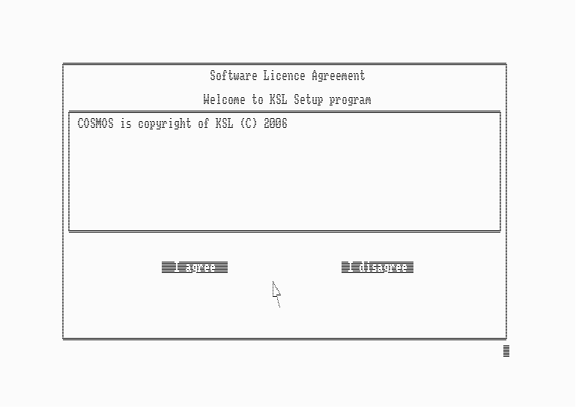
COSMOS Installation Module

You can install COSMOS in your external drive B: or in any partition of your CPC Hard disk. For the user convenience, a demo version can be installed so that the user can get familiar with the software modules. Cursor keys or mouse can be used in order to navigate through the installation options.

Execution

After the installation has been successfully completed, you are ready to run COSMOS. Move to the destination drive (e.g. B:) and edit B>COSMOS. There are three execution modes a) Standard mode b) Advanced mode and c) Restart mode. You can select Standard or Advanced mode using your mouse pointer. If you click on the right mouse button you can Restart an unfinished analysis.

In Standard Mode, input and output are performed by accessing the data from the floppy disk in-situ.

In Advanced mode, the total annual project is loaded in RAM expansion. Thus the processing speed increases dramatically and data save is optional. Advanced mode requires at least +256 kB of additional RAM and is not supported for 128 kB RAM machines.

Restart analysis can be used in case of an I/O error or in case of a user break. Furthermore, if running in Advanced mode (thus all project data remain in RAM expansion), the user can quit without saving, run some other applications (e.g. ProText/ProWort, CPC-Word, Mini Office II) and then continue his unfinished analysis by restarting COSMOS.

Main modules

The main screen provides the basic tools for cost monitoring.

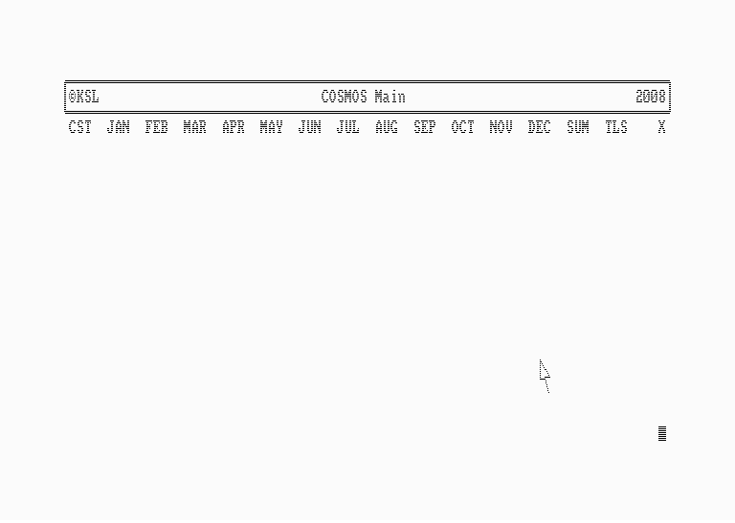
COSMOS Main screen

At the beginning of the annual project, the user must edit his constant or periodical income or expenses by clicking on CST option.

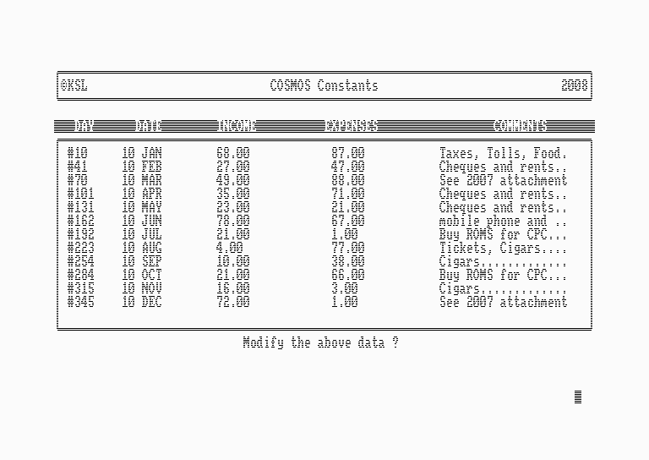
COSMOS Constant module (editing 10th of each month)

All other expenses (or income) are specified by editing the cost matrix of each month (from JAN to DEC). There is space for up to 10 sequential inputs plus a text comment for each day.

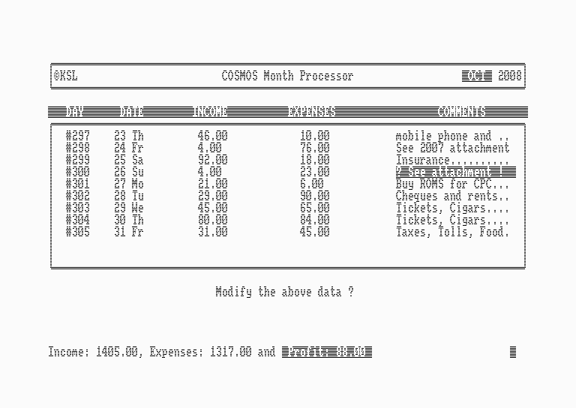
COSMOS Month Processor (October, 2008)

The SUM module will calculate your available cash any time of the year. Thus the user can easily plan his expenses in order to avoid negative cash and to maximize his profit. The SUM module will also export a full review text file for further post processing using Amstrad CPC or Microsoft Excel. This review file will also stamp your directory with the annual project.
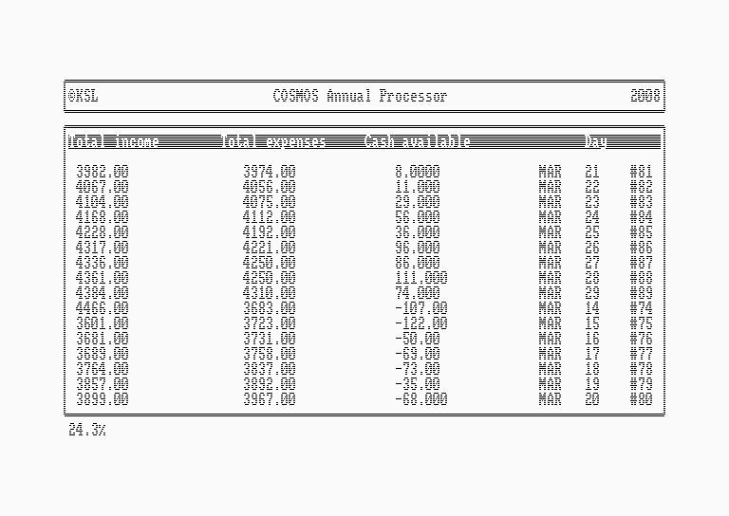
COSMOS SUM module – Annual processor

2D–Graphs and facilities for the printer and serial interface are also supported.

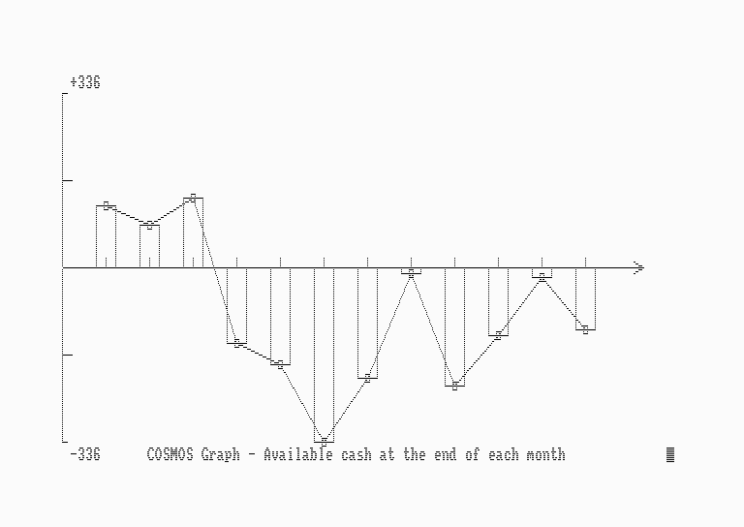
COSMOS 2D graph
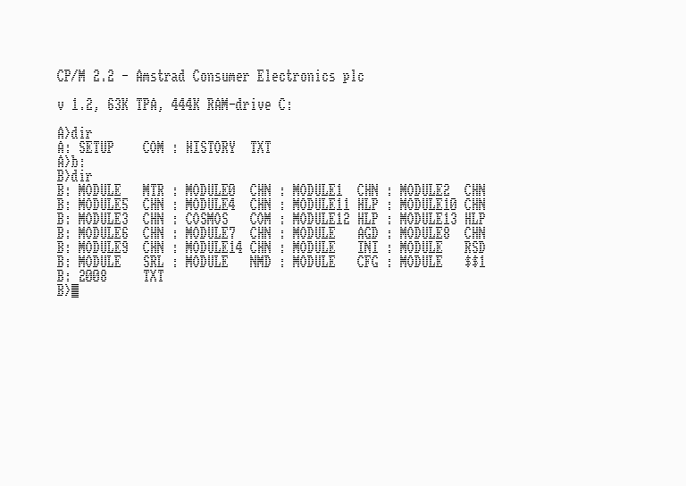
Annual project of 2008 (see review file 2008.txt)

Additional Tools

For more efficient cost monitoring, COSMOS provides additional tools. These are the residual module, the Name – day generator, the attachment editor, the net profit calculator, the search module, the overview module, the agenda module, the taxation module, the alert module and a few modules that deal with the CPC memory resources.

Residual module can be used in order to modify the cash residual of the last year, edited during installation. The Name day generator will create the day names matrix (Mon..Sun) for all days of your annual project. Attachment editor is a Notepad – like editor and can be used in order to edit additional comments beyond the comments edited for each day.

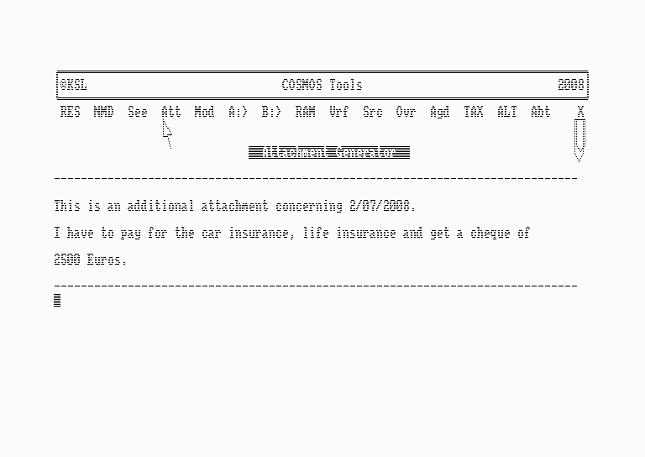
COSMOS Tools, running Attachment generator

The net profit calculator will calculate your net profit without taking into account the cash residual of the previous year. Search module will look for specific costs edited in your cost matrix and will calculate the total expenses concerning a specific cost (e.g. Car Fuel or Ebay). Overview module provides the ability to directly access all your annual project and to edit your daily agenda.
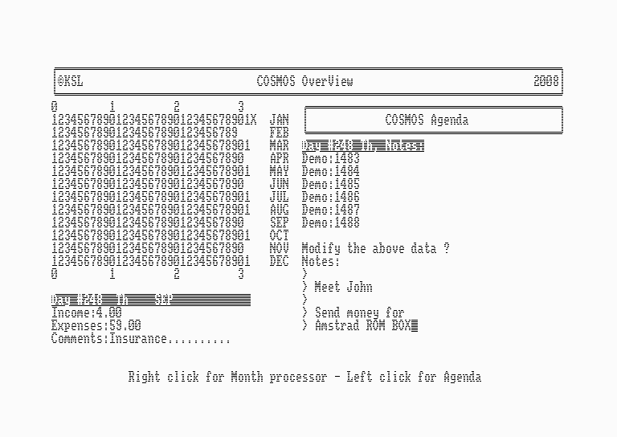
COSMOS Overview and Agenda editor

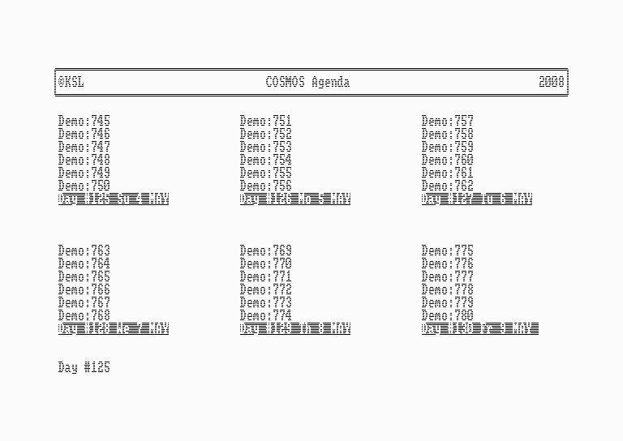
COSMOS Agenda

Taxation module calculates the amount of tax return depending on your net annual income, expenses and taxation factors. Finally, the Alert module will keep an alert eye on the profit of a specific day.

Multiple Annual Projects
You must re–install the software for each annual project. If you have a large capacity disk drive (720–800 kB) you can move each project to the relevant directory user (project of 2008 in user 8, etc). Thus you can keep a few annual projects on the same disk. If you have a lot of RAM expansion you can run different annual projects at the same time in Advanced mode. COSMOS requires minimum 162 kB of disk space and min 110 kB of RAM expansion for each annual project. User attachments are not included in this.

GUI
COSMOS Graphic User Interface provides mouse support in order to facilitate user selections. A color screen saver is also activated when necessary. On board help is also supported.

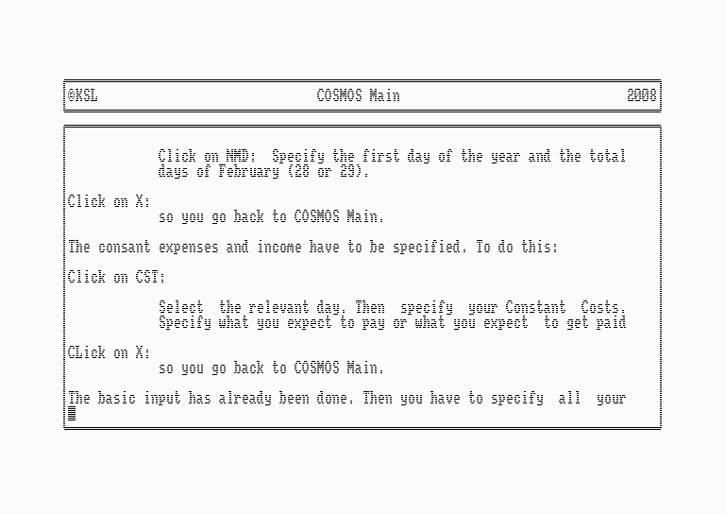
COSMOS On board help

Performance
COSMOS is very stable and fast. Speed decreases as you fill in the cost matrices. If your Amstrad is fully upgraded (+512 kB, 720 kB external drive, Mouse, HD) you get the feeling of working with an IBM Compatible like PC1512 or PC1640.

Feedback
Feel free to contact KSL for any question or suggestion.

